***Content Outline***

The contents that were included in my website are:

* Home – That shows the home screen, first page of the website
* About Me – When clicked, it displays information about me in a different page
* Skills – When clicked, it displays my skill set in an ordered list.
* Contact Me – When clicked, it displays my contact information.

There is an option called “Download”. It is a button which when clicked, automatically downloads my resume onto the system.

There is footer which displays the copyrights to whom it is concerned to.

An image of mine has been included in the first page which acts as a profile picture.

Also LinkedIn link has been provided on the first page which when clicked in the image, takes you to the linked in profile of the candidate. An image has been included under the download button.

The styling has been included for the whole website in the styles.css file.

It contains the styling for each page and has different colors and different font types and sizes.

Some of the stylings that were used are:

1. text-align: center; 🡪 This has been given for all pages, when it aligns the text in the center.
2. background-color: #b5ba60; 🡪 A background color is given for all the pages and #b5ba60 depicts a light yellow color as shown below:

As per the screenshot below, the colors has been chosen;

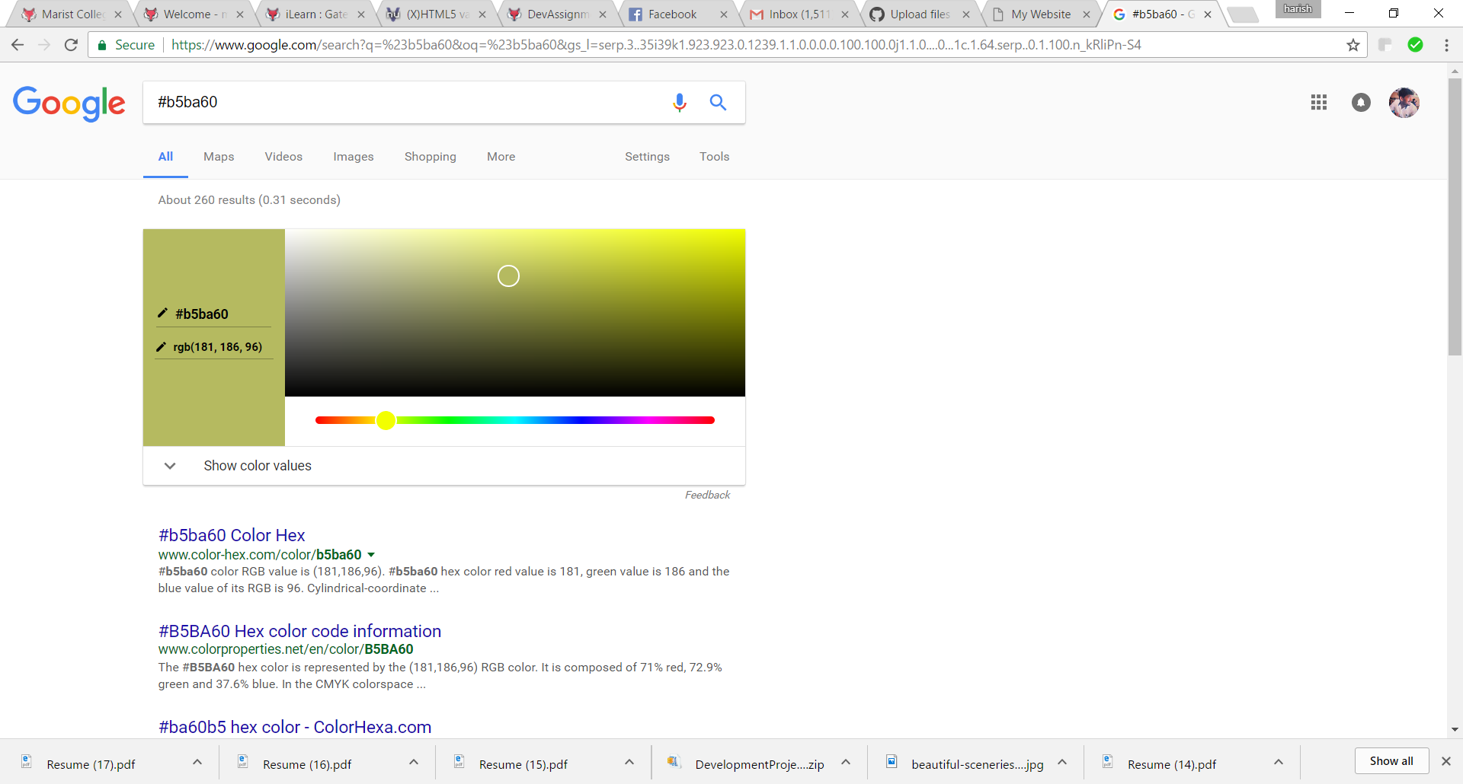

1. font-size: 16px 🡪 It sets the font size for the fonts used in the website and has been used extensively across the website for various tabs within. px means pixels.

There are many others that are used in the css file.